

Name::Shriyansh kela
Registration Number:24BCE11400
Project title: Open Source Audit
Course Name: Open Source Software

Introduction:
Open source software is the heartbeat of our modern digital world. At its core, it’s all about freedom—the source code is right there for anyone to look at, use, tweak, or share. Unlike closed, proprietary systems that keep their secrets locked away, open source thrives on collaboration and transparency. It’s incredible to think about developers from every corner of the globe coming together to fix bugs, polish features, and constantly make things better. This shared passion is exactly what makes open source tools so reliable, adaptable, and accessible to everyone.
Today, it’s almost impossible to find a system that doesn’t rely on open source technology. From the Linux operating systems powering massive servers to the programming languages and tools we use every day, open source is the true backbone of the tech industry. It’s not just about saving money; it’s about the power to customize software to fit your specific needs. This level of control is a game-changer for students, independent developers, and major organizations alike.
Take Python, for example—one of the most beloved open source languages out there. People love it because it’s remarkably easy to read and has a straightforward syntax that just makes sense. You’ll find Python everywhere: in web development, AI, data science, and automation. Because it feels so approachable, it’s almost always the first recommendation for anyone looking to start their coding journey.
In this project, we’re diving into an audit of Python as an open source powerhouse. We’ll explore where it came from, how its licensing works, the ethics behind it, and its vital role within Linux systems and the broader ecosystem. Our goal is to look beyond the code and understand the philosophy and real-world impact that makes open source software so influential.
Origin & Philosophy:The Problem Python Was Created to Solve:
Late in the 1980s, coding seemed locked behind walls. Though tools such as C and C++ offered strength, they demanded steep learning curves - programmers battled tangled rules and deep machine logic even for small jobs. Because of that friction, Guido van Rossum aimed elsewhere, launching his own creation by 1991.What made things tough was just getting into the code. Fixing errors took forever, while writing it drained time fast. A new kind of language had to show up - one clear enough to feel like everyday speech, yet strong enough to handle complex tasks without needing stacks of instructions for basic jobs.What Guido built started as an idea about clarity taken to extremes. From ABC, he borrowed concepts - then shaped them into something easier to grasp on first sight. Code could now show intricate thinking without clutter or confusion. This went beyond utility; it quietly pushed coding closer to how people actually think.Right from the start, Python opened its doors wide. Instead of keeping control tight under one company roof, Guido set it free for anyone to use. Because of that move, people everywhere began shaping it in their own way. Driven by countless hands across continents, it grew faster than most expected.One idea stands out when thinking about how Python works: "There should be one - and ideally just one - clear way to get things done." What makes Python different is its focus on being clear instead of tricky, turning it into a favorite tool for beginners along with experts who study huge amounts of data.Out in today's tech world, Python runs much of what we see online and inside smart systems. Because it made tough tasks easier and opened doors for more people, its role grew beyond trendiness - now shaping how friendly tools come together by design.
The License — What It Actually Says:
Talking about open source? The license shapes everything - it holds the legal rights behind every freedom claimed. For Python, that role belongs to the unusually open Python Software Foundation License. Called the PSF License, it allows broad use. Permissive by design, this type of license removes barriers instead of adding them. Saying yes to new ideas sits at its core.Python thrives thanks to its open license - legal ease plays a big role. Freedom to use, tweak, and share the core tool comes without red tape, whether you are one person learning or part of a giant firm building closed tools. What sets it apart? Firms can alter Python’s inner workings privately while keeping those updates secret when selling finished software. That ability to innovate behind closed doors encourages wide corporate trust. Risk drops. Adoption grows. The result: steady reliance on Python in business-critical systems.Freedoms sit at the heart of the PSF License, rooted deeply in how free software works. Because openness matters, its design follows the four key rights that shape genuine access.Here’s what you’re always allowed to do with Python, thanks to its licenseFreedoms start here: running the software fits every goal you might have. Whether it's your own projects, school needs, business tasks, or public work - it works. Purpose? Not restricted in any way.Starting fresh means seeing every line of code up close. Changes fit what you actually do, because control stays in your hands. A different path opens when rules allow adjustments without asking first. Working directly with the software removes barriers most never notice. Full visibility leads to better understanding over time. Custom tweaks become possible only if restrictions are truly lifted.Sharing the program freely lets others join in, spreading access further through simple giving. What begins small moves outward when people pass it along without barriers.Freed to tweak things your way, sharing those tweaks openly lets everyone build on them - language moves forward because of that flow.What sets the PSF License apart is how much room it gives users, especially next to something like the GNU GPL. Far from locking things down, it skips strict rules about redistribution. Instead of forcing changes into the open, it lets people decide their own path. With the GPL, altering code means giving back - same license, same openness, every time. That chain stays unbroken by design.Still, the PSF License works without copyleft rules, drawing comparisons to the loose structure of the MIT License. Open use matters more here than requiring shared changes back. That path shaped how Python moved forward, favoring presence across many kinds of software - free or proprietary - instead of pushing openness through legal strings. Influence ran deep, steering clear of strict return policies for code.In the end, you have to see the difference - one kind of free means zero price, another means real liberty. Python lives by both ideas. Zero dollars needed to grab a copy; that covers the "free beer" part. Even better, people can dig into how it works, change its code, pass on their versions - total control, in other words. That mix of strength, openness, and ease fits business needs just fine. Over time, this setup helped make Python everyone's go-to tool online, sparking fresh thinking nearly everywhere tech reaches.
The Ethics of Open Source:
What if every program came with its secrets out in the open? Free to peek, tweak, build - that’s how some see software, not just lines but a mindset. Built on openness, meant for anyone willing to dive in, change things, grow skills. But here’s one thought: ought every tool we use live under glass like this?When software is open for everyone to see, trust grows naturally. Anyone might look under the hood, spotting flaws or dangers before they cause harm. Learning becomes simpler when examples are free to explore, especially for those starting out. Faraway coders sometimes team up without ever meeting, pushing ideas forward at odd hours. Quality often rises when many eyes and hands shape the same tool.Still, not everyone agrees that every program should be freely shared. Companies often spend years building tools, hoping to make back what they put in. Should all code become public, firms could find it harder to stand out. At times, locking down access helps guard private information or critical operations.Open source software fuels many commercial products, yet questions linger about fairness. Big firms often rely on tools such as Python or Linux to create services they sell. While some improvements get shared - fixing bugs, adding features - not every benefit flows back. Profits grow while contributions sometimes fade into silence. One view celebrates progress through collaboration; another sees imbalance when gains outweigh giving. When value is extracted at scale, eyes turn toward reciprocity. The debate isn’t new - but it shifts shape each time a startup rises on free code.Looking back, progress usually rests on earlier efforts. That old saying about standing tall thanks to those before us fits well. New ideas tend to grow from what was already done. Because people share code freely, building onward gets simpler. One person's work becomes a base for someoneelse. Improvements happen faster when access isn’t blocked. What exists today helps shape tomorrow’s tools. Sharing widens the path ahead instead of narrowing it.Open source tips the scale where giving meets creating. Learning happens here, collaboration follows closely behind. Better tech grows when minds work together like this. Yet effort deserves recognition too - always remember that. Developers pour time into code; their labor counts just as much. Support shows up in many forms: help shared, money offered, attention paid. Community thrives when those using it also feed it slowly.
Linux Footprint of Python:
Introduction:Often tucked into Linux setups right out of the box, Python shows up by default across countless distros. From running small scripts to building full apps, it quietly supports core system tasks. Seeing where Python lives on the machine, how tools handle updates, and when programs call it reveals real-world habits.
Installation Method:Python can be installed in Linux using the package manager. In this project, Python was installed using the following command:
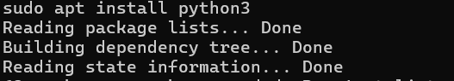
Checking Python Version:After installation, the version of Python can be verified using:
File Locations in Linux:
User and Permissions:

Service Management:
Running Python does not make it a background process. Yet programs written in it often power tasks behind the scenes. When tied to tools like Apache or Jenkins, its role expands quietly. Scheduling those scripts? That happens through utilities such as cron. Automation runs on time thanks to that setupution.
Conclusion:
Out of the box, Python works smoothly on Linux. Following common folder setups comes naturally to it. Package tools handle its setup and patches without fuss. Running under regular user access keeps things locked down tight. Efficiency finds a home here, along with trustworthiness, inside that ecosystem.
The FOSS Ecosystem of Python:
Introduction:
Software made by many people never stands alone. Thanks to countless helpers worldwide, Python thrives inside a busy network of add-ons, helpers, and clever code bits. That shared world gives it strength, pulling in users from everywhere. Its reach grows because others build beside it, not just around it.
Dependencies of Python:
What keeps Python running smoothly? A handful of helper tools and code collections. At the top stands pip - think of it as a librarian for software bits. When someone needs outside code, this tool steps in quietly. Getting new parts works without clutter or confusion. Organization happens behind the scenes, smooth and steady.
Running well needs tools already built into Linux, like system libraries plus compilers. Because of these pieces, Python talks to the OS without getting stuck. Tasks move faster when the right parts are nearby under the surface. Without them, even basic jobs would slow down unexpectedly. They handle behind-the-scenes work so Python does its job quietly.
Libraries and Frameworks:
Packed with tools, Python shines because people worldwide build and update its modules together. This shared effort keeps everything running smoothly across projects.
A few well known ones are:
NumPy → used for numerical computations
Pandas → used for data analysis
TensorFlow → used for machine learning and AI
Django → used for web development
Flask → lightweight web framework
Fueled by these tools, Python fits many kinds of tasks. Despite their simplicity, they open doors across different fields.

What Python Has Enabled:
Possibly the most flexible tool around, Python helps build today's tech scene. Found almost everywhere, it powers everything from web apps to data systems
Artificial Intelligence and Machine Learning
Data Science and Data Analysis
Web Development
Automation and Scripting
Cybersecurity
A single reason Python shows up so much? It stays out of the way while things get built. Simplicity helps, sure - yet it's how easily one thing connects to another that really matters. Built-in room to stretch lets ideas take shape without fighting the code. Flexibility becomes invisible when everything just moves together.
Role in the Software Ecosystem:
Out of nowhere, Python shows up across much of today’s software world. Web setups often bundle it with Linux, Apache, and MySQL - swapping between Perl or PHP depending on taste.Open-source tools fit together smoothly, so this plays an essential role in today’s software building. Yet its real strength shows when linked with different tech platforms.
Community and Governance:
Folks who use Python stick around, they keep showing up. Behind the scenes, a group called the Python Software Foundation nudges things forward - guiding changes while making sure it doesn’t lose momentum.
The community contributes through:
Open-source contributions on GitHub
Online forums like Stack Overflow
Conferences such as PyCon
Because people work together, Python keeps changing in ways that matter. New ideas flow easily when users share them openly across communities. Updates come regularly thanks to open feedback loops between developers worldwide. Each contribution shapes how the language grows over time. Progress happens step by step through shared effort.
Conclusion:
Pull back the curtain, Python thrives thanks to more than syntax alone. Its muscle comes from tools stacked high - libraries here, frameworks there. Community energy fuels it daily, feeding updates, fixes, patches. That mix turns code into something flexible, ready for almost any task. Around the globe, people lean on it, rely on it, build with it. Open source? Yes - but feel how alive it acts.
Open Source vs Proprietary:
Introduction:
A look at how Python stacks up against closed software kicks things off here. Open code versus locked-down tools shows clear trade-offs when used outside theory. Real situations reveal where free-to-use programs shine, also where they struggle.Python takes center stage here, set beside Java - a language shaped by stricter rules and corporate environments.
Comparison Table:

Dimension | Python (Open Source) | Java (Proprietary-Oriented)
Cost | Free to use and distribute | Requires paid tools in some cases
Security | Source code is open for auditing | Source code is closed
Support | Community-based support | Official corporate support
Freedom to Modify | High — users can modify freely | Limited modification rights
Control | Community-driven | Corporate-controlled
Analysis:
Freedom flows through Python since it is open source. Because of that, tinkering with the code fits naturally into how people work. Sharing versions happens freely, no barriers get in the way. Its use stretches across tasks, unrestricted by rules. Learning finds a friend here, so does exploring ideas or building fast.
Yet Java holds firm in corporate settings, backed by major players across industries. Performance? A strength. So are scaling well under load and staying steady over time. Still, it lacks the open reach found in tools like Python, where fewer limits shape how people build.

Conclusion:
Open-source tools such as Python matter deeply in today's tech world - because they invite teamwork, spark new ideas, often cost nothing to use. Though closed systems bring some advantages, freely shared code tends to offer greater flexibility, room to evolve. When people examine both paths closely, one truth stands out: openness fuels progress more openly. Freedom to tweak, share, build - that shapes how technology moves forward.
Shell Scripts:
Introduction:
One way people work with Linux is by writing small programs called shell scripts. These little tools run steps one after another without needing someone to type each time. For this task, basic scripts came together to show what happens when Python meets Linux. The idea was seeing how both pieces fit in everyday system jobs.
Script 1: System Identity Report:
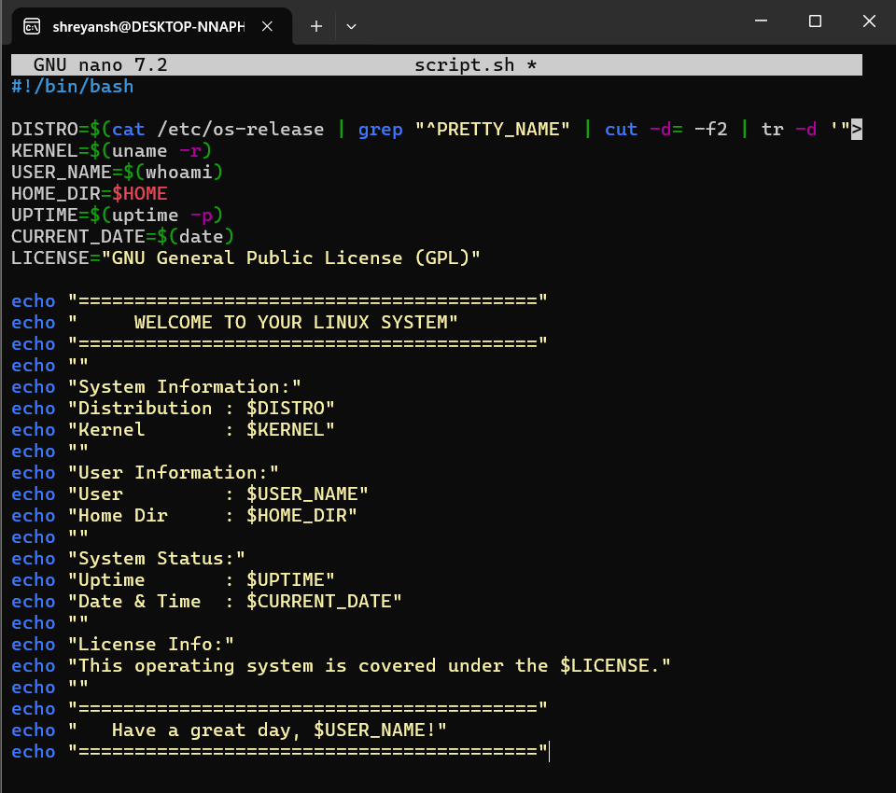

Output:
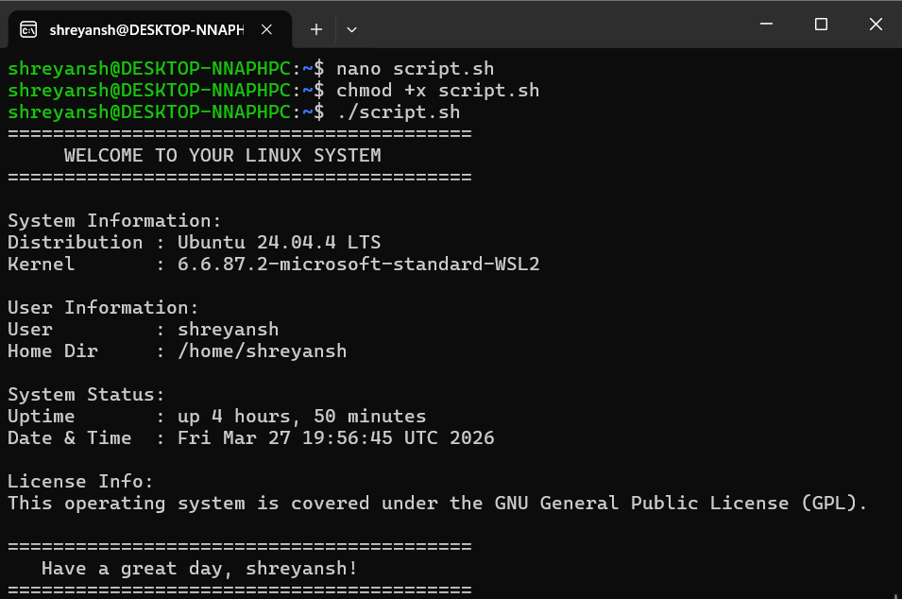

Script 2: FOSS Package Inspector:
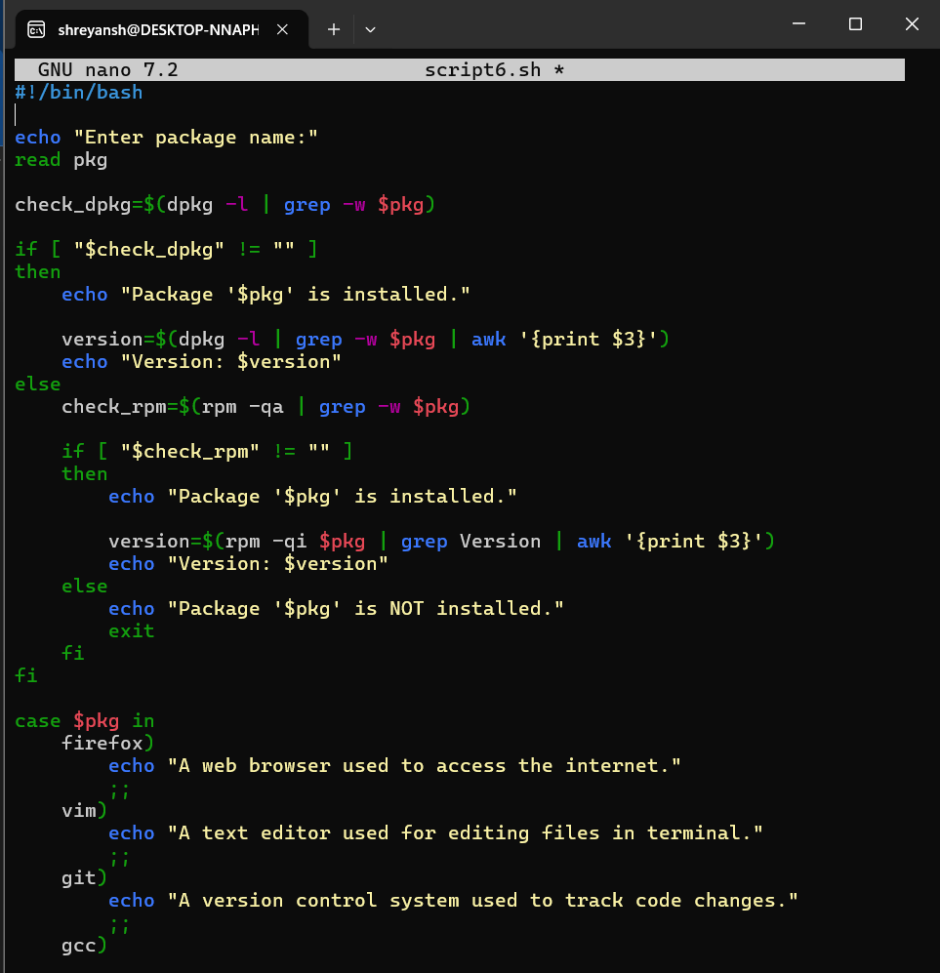
OUTPUT:
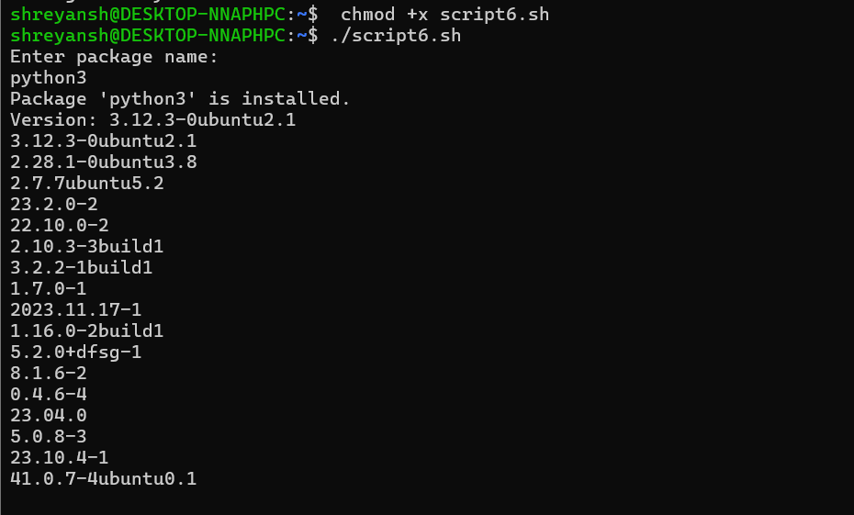

Script 3: Disk and Permission Auditor:
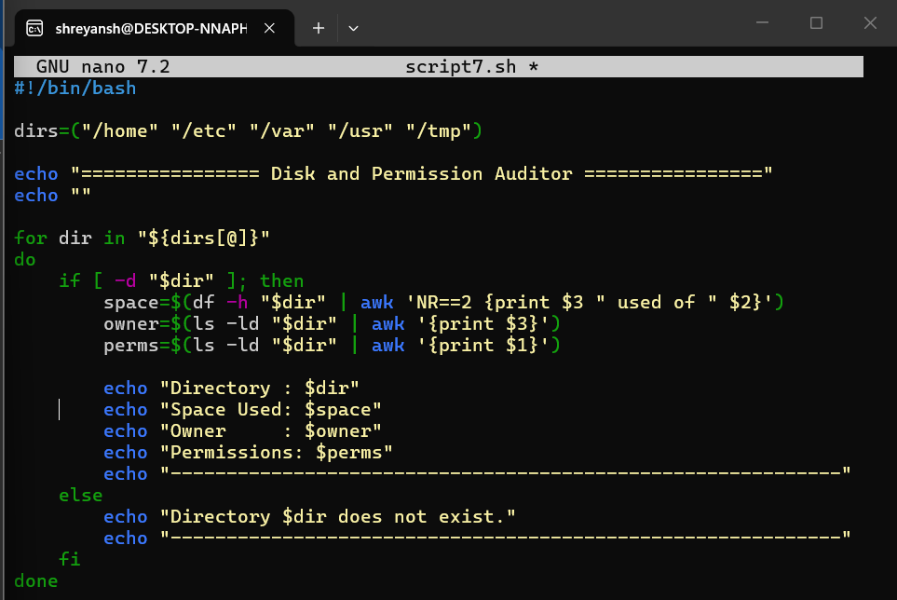

OUTPUT:
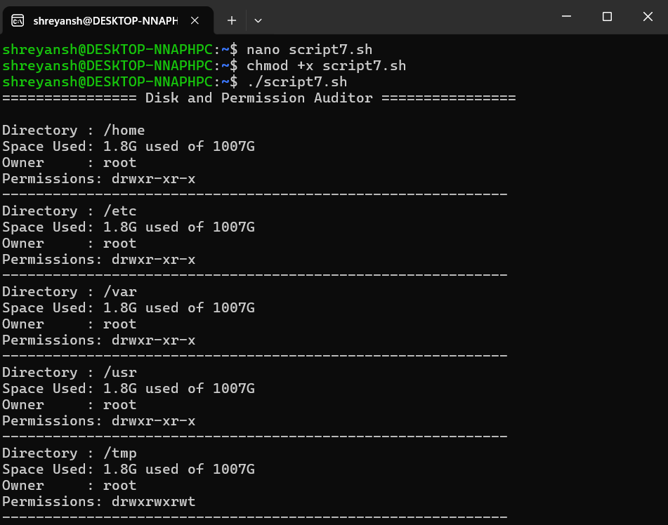

Script 4: List Installed Python Packages:
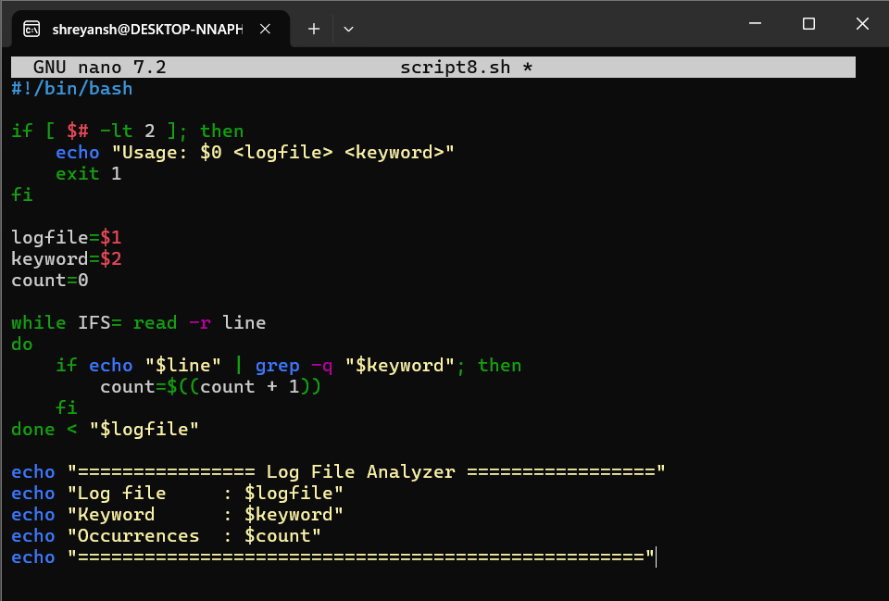

OUTPUT:
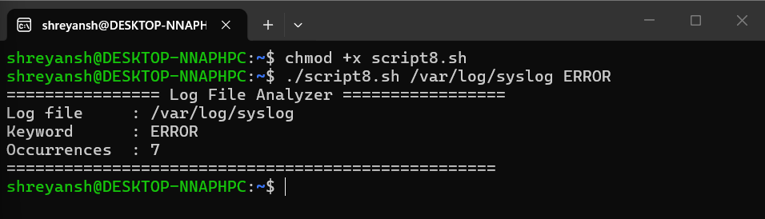

Script 5: Disk Usage and Python Location:
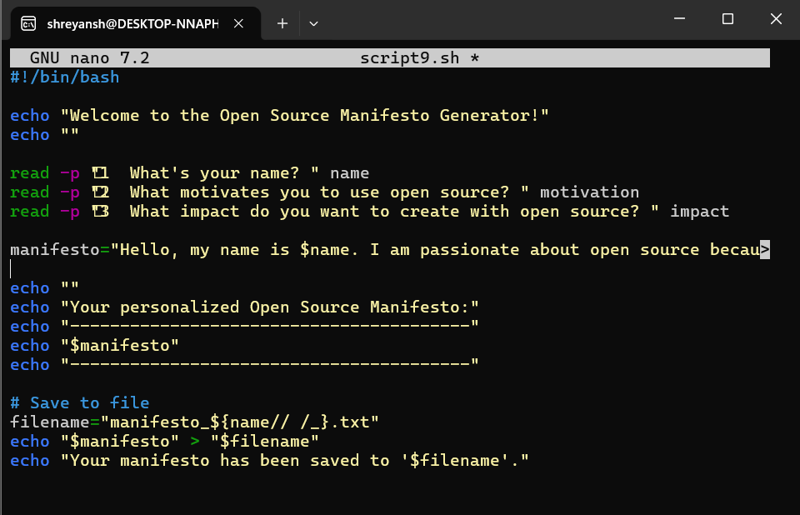

OUTPUT:
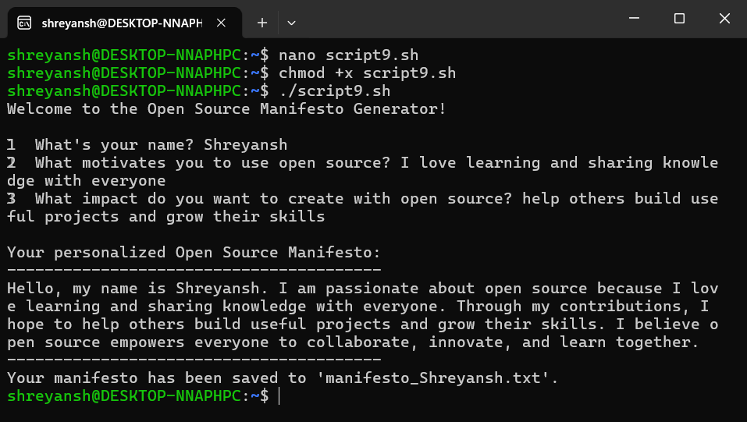
Conclusion of Shell Scripts:
From those scripts, a clear picture emerges - Linux shell scripting links smoothly with Python to handle repetitive jobs. Though basic in design, they show strength when open-source pieces join without friction. Efficiency hides in their simplicity, each line doing its part without extra noise.

Final Conclusion:

Conclusion:
What started as a way to make coding less messy turned into something much bigger. Through this work, Python’s place in today’s tech world got a close look. A clear, straightforward design helped it stand out early on. Because of how easy it is to understand, people everywhere began using it. Slowly, without loud announcements or fanfare, it climbed to the top. Now, it powers countless tools, apps, and systems across industries.
Freedom lives inside Python's rules - built on a license shaped by its foundation. Open doors appear when people tweak, share, or build on the code. Ideas cross borders because trust grows in shared spaces. Progress often follows where access is free.
Python setup on Linux became clearer by exploring the terminal inside Ubuntu running through Windows Subsystem for Linux. Tools like python3 --version showed what version runs on the machine. The command which python3 revealed where it lives in the file structure. Who am i gave insight into user permissions tied to those operations. Each step unfolded part of how Python connects with the operating system underneath.
Nowhere else do tools blend so well with community effort like they do around Python. Libraries pop up where needed, guided by steady backing from the Python Software Foundation. Often seen in labs and startups alike, its presence grows through real work - think smart algorithms, number crunching, website backbones. Not loud, yet everywhere, shaping how problems get solved across fields.
Starting with control, proprietary tools deliver organized help straight out of the box. Yet when it comes to tweaking things freely, open options pull ahead - no surprise there. A language like Python? It grows fast because regular people shape it daily. Simplicity keeps it alive; not fancy rules.
Putting together shell scripts showed just what happens when Linux tools meet Python code. Through these examples, handling everyday computer tasks became something you could see and do.
Ultimately, working on this effort made clear how open-source tools blend idea work with real-world use. It turns out Python stands strong - adaptable, straightforward, yet influential - as tech moves forward.

References:
Official Python Website
👉 https://www.python.org
Python Documentation
👉 https://docs.python.org/3/
Ubuntu Official Website
👉 https://ubuntu.com
GitHub
👉 https://github.com
WSL Documentation (Microsoft)
👉 https://learn.microsoft.com/en-us/windows/wsl/

